EVS CLASS TEST -1 FM : 10
Date: 21/4/25
MCQ. (1x4=4)
1.The landform -plateau is present in which part of our country.
a) North
b) South
c) East
d) West
2.A pulley is used to –
a) increase the effort to lift ,pull or move an object.
b)make out work harder.
c) reduce the effort to lift, pull or move an object.
d)move a vallam.
3. Brahmaputra flows through
a) the great Indian desert
b) Deccan plateau
c) Kerala
d) Northern plains
4. Snowy mountains are found in
a) Rajasthan
b) Kerala
c) Ladakh
d) plains
Answer the following questions:(2x2=6)
5.On cement bridges trucks and buses can move easily than bamboo bridges. Give 2 reasons.
6.Name the states ,where in few places children reach school by-
i) vallam
ii) camel carts
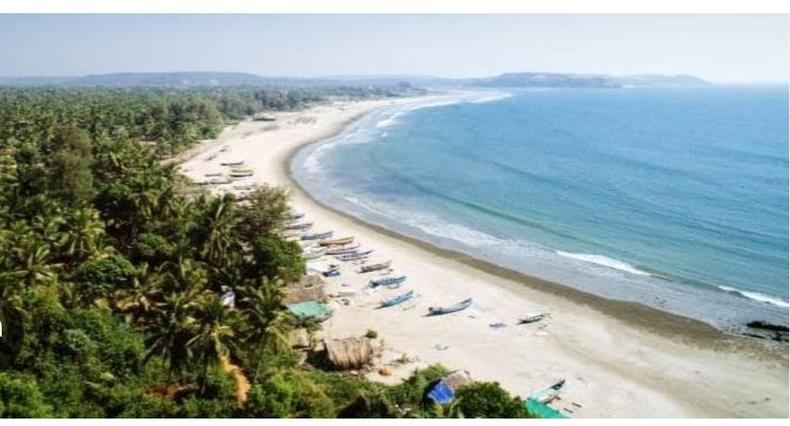
7.Explain about the type of landform that you can observe in the given picture

